BALSALL COMMON & MERIDEN GROUP PRACTICE
Confidential New Patient Questionnaire (16+)
Title | Surname/Family name |  |  | Given Name |  |  | Middle Names
Marital status | Previous Surnames |  |  | Name known as |  |  | Date of Birth
House Name or Number |  | Street |  |  | Area
Postcode |  |  | Home Telephone No
Work Telephone No |  |  | Mobile |  |  | Email:

Occupation

Next of Kin

Full Name

Relationship

Address
House Name and Number
Street
Town
Post Code

Contact Telephone Number

This Practice uses text messaging for Practice appointment reminders, Practice news or advice about your health and Group reminders (eg Flu vaccine).

I DO/DO NOT wish to be contacted via text message (Please delete as appropriate)

Signed .................................................................... Date ...........................................

Please note In order to maintain confidentiality, it is your responsibility to contact the Practice and update any changes to your mobile number. If you wish to opt out of receiving text messages at any time, please contact us.

Who is a Carer? A Carer is someone, who, with or without payment, provides help & support to a partner, child, relative, friend or neighbour, who could not manage without their help. This could be due to being elderly, have a physical or mental illness, addiction or disability. We would be grateful if you could complete the boxes below to ensure we can offer you (if you are a Carer) or your Carer the correct help & support
Are you a Carer? Yes/No | If yes, for whom?
Do you have a Carer? Yes/no | Name of Carer
Address & Contact Details for Carer
Signed / Agreed by Patient

Allergies - We especially need to know of any drug allergies and the effect they have on you, please include non-drug allergies if they have a significant effect on your health.

……………………………………………………………………………………………………………………………………………………….

……………………………………………………………………………………………………………………………………………………….

……………………………………………………………………………………………………………………………………………………….

Your Height | Your Weight

Diet: Please indicate which option best describes your usual diet
Poor | Average | Good | Special Diet (Please give details)

Exercise: Please indicate which option best describes your exercise regime
Light | Moderate | Heavy | Avoid it | Own health prevents it

Medication

Please note - If you are on regular medication please make an appointment with a doctor before your next prescription is due, and bring with you your current medication repeat slips or boxes / bottles of your medications. If you use an asthma inhaler please make an appointment with the asthma nurse.

Do you Smoke?  Yes/No | If ‘Yes now many | Have you ever smoked?  Yes/No | When did you give up?
At the Practice we have dedicated Nurses who are fully trained in smoking cessation that can help you. They can assess your readiness to stop, discuss treatment options (not only nicotine replacement products but modern drugs that can stop cravings) and give ongoing support.

I would like one of the Practice Nurses to contact me regarding helping me to stop smoking – YES/NO

I would like one of the Practice Nurses to contact me regarding Nicotine Replacement Therapy Treatment – YES/NO
Units of Alcohol

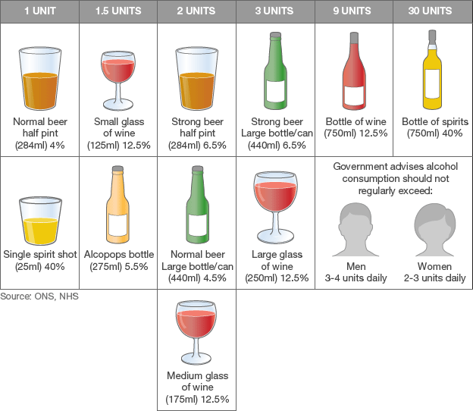
Alcohol Consumption: | Please circle the appropriate answer. |  |  |  |  | Scores: to be completed by the surgery
How often do you have a drink that contains alcohol? | Never | Monthly or less | 2-4 times per month | 2-3 times per week | 4+ times per week
How many units of alcohol do you have on a typical day when you are drinking? | 1-2 | 3-4 | 5-6 | 7-8 | 10+
How often do you have 6 or more units on one occasion? | Never | Less than monthly | Monthly | Weekly | Daily or almost daily
Scoring (for practice use) | 0 | 1 | 2 | 3 | 4
Total score:
A total of 5+ indicates increasing or higher risk drinking
An overall total score of 5 or more is AUDIT C positive. Read code 38d4

Alcohol Consumption | Please circle the appropriate answer. |  |  |  |  | Scores: to be completed by the surgery
How often during the last year have you found that you were not able to stop drinking once you had started? | Never | Less than monthly | Monthly | Weekly | Daily or almost daily
How often during the last year have you failed to do what was normally expected from you because of your drinking? | Never | Less than monthly | Monthly | Weekly | Daily or almost daily
How often during the last year have you needed an alcoholic drink in the morning to get yourself going after a heavy drinking session? | Never | Less than monthly | Monthly | Weekly | Daily or almost daily
How often during the last year have you had a feeling of guilt or remorse after drinking? | Never | Less than monthly | Monthly | Weekly | Daily or almost daily
How often during the last year have you been unable to remember what happened the night before because you had been drinking? | Never | Less than monthly | Monthly | Weekly | Daily or almost daily
Have you or somebody else been injured as a result of your drinking? | No |  | Yes, but not in the last year |  | Yes, during the last year
Has a relative or friend, doctor or other health worker been concerned about your drinking or suggested that you cut down? | No |  | Yes, but not in the last year |  | Yes, during the last year
Scoring (for practice use) | 0 | 1 | 2 | 3 | 4

Scoring: 0 – 7 Lower risk, 8 – 15 Increasing risk,
16 – 19 Higher risk, 20+ Possible dependence
Total score equals score above+ audit C
Read code 38D3
Total score:

PATIENT ETHNIC ORIGIN QUESTIONNAIRE

We have been asked by the NHS to collate ethnic origin details of new patients registering at the practice.

Please tick ONE box which indicates your ethnic origin.

It is not compulsory to complete this form, although knowledge of your origins may help in early diagnosis of some conditions more common in specific communities.

Name…………………………………………………………………… Date of Birth…………………………

White

[ ] British
[ ] Irish
[ ] Any other background please specify below
……………………………………………………………………..
Mixed

[ ] White and Black Caribbean
[ ] White and Black African
[ ] White and Asian
[ ] Any other background please specify below
……………………………………………………………………..
Asian

[ ] Indian
[ ] Pakistani
[ ] Bangladeshi
[ ] Any other background please specify below
……………………………………………………………………..
Black or Black British

[ ] Caribbean
[ ] African
[ ] Any other background please specify below
……………………………………………………………………..
Chinese or other ethnic group

[ ] Chinese
[ ] Any other ethnic group background please specify below

……………………………………………………………………..
First Language

……………………………………………………………………………………………………………..

……………………………………………………………………..

Religion

……………………………………………………………………………………………………………..

For further information about the Practice, please see the Practice leaflet or visit our website
www.balsallcommongrouppractice.co.uk

Management of Patient Information- Notice For Patients
Your Information, Your Rights
Our Management of Patient Information process explains why we collect information about you and how that information may be used to deliver your direct care and manage the local health and social care system.
The process reflects:

• What information we collect about you;
• How and why we use that information;
• How we retain your information and keep it secure;
• Who we share your information with and why we do this.

The process also explains your rights in relation to consent to use your information, the right to control who can see your data and how to seek advice and support if you feel that your information has not been used appropriately. A full copy of the Management of Patient Information process is available on our website or on application to the Practice Manager.
In addition detailed below is the Practice "Subject Access Request Policy". This policy details the process for the management of requests for personal information (for living individuals) under the Data Protection Act (DPA, the General Data Protection Regulations (GDPR) and (for deceased individuals) the Access to health Records Act 1990.

YOUR CARE CONNECTED is a local Birmingham & Solihull service which will allow doctors, nurses and other registered healthcare professionals to view information from a patient’s record, with the patient consent to provide better, safer care. More information about this service is included within this pack including an opt out form if required.

The SUMMARY CARE RECORD (SCR) is an electronic record of important patient information, created from GP medical records. It can be seen and used by authorised staff in other areas of the health and care system involved in the patient's direct care. More information about this service is included within this pack including an opt out form if required.

Signed ........................................................................................... Date .................................................................................

